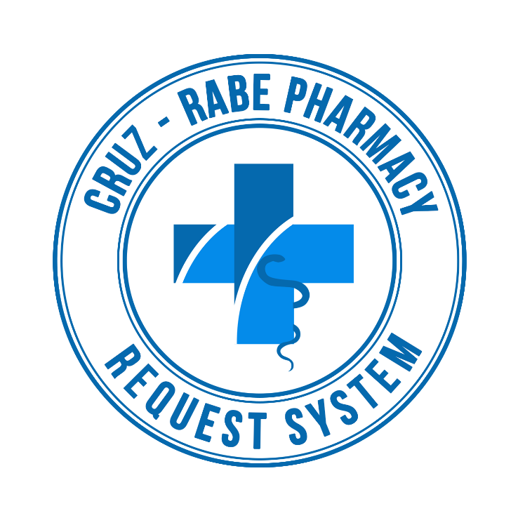

**Change Management Plan**

**Cruz – Rabe Pharmacy Request System**

**Table of Contents**

Introduction 2

Change Management Approach 2

Definitions of Change 2

Change Control Board 3

Roles and Responsibilities 3

4Change Control Process 4

# Introduction

The Change Management Plan was created for the Cruz-Rabe Pharmacy Request System Project in order to set expectations on how the approach to changes will be managed, what defines a change, the purpose and role of the change control board, and the overall change management process. All stakeholders (Client, Project Team, Adviser, Consultant) will be expected to submit or request changes to the CRPRS Project in accordance with this Change Management Plan and all requests and submissions will follow the process detailed herein.

# Change Management Approach

The Change Management approach for the CRPRS Project will ensure that all proposed changes are defined, reviewed, and agreed upon so they can be properly implemented and communicated to all stakeholders. This approach will also ensure that only changes within the scope of this project are approved and implemented.

The Change Management approach is not to be confused with the Change Management Process which will be detailed later in this plan. The Change Management approach consists of three areas:

* Ensure changes are within scope and beneficial to the project
* Determine how the change will be implemented
* Manage the change as it is implemented

The Change Management process has been designed to make sure this approach is followed for all changes. By using this approach methodology, the CRPRS Project Team will prevent unnecessary change from occurring and focus its resources only on beneficial changes within the project scope.

# Definitions of Change

There are several types of changes which may be requested and considered for the CRPRS Project. Depending on the extent and type of proposed changes, changes project documentation and the communication of these changes will be required to include any approved changes into the project plan and ensure all stakeholders are notified. Types of changes include:

* Scheduling Changes: changes which will impact the approved project schedule. These changes may require fast tracking, crashing, or re-baselining the schedule depending on the significance of the impact.
* Budget Changes: changes which will impact the approved project budget. These changes may require requesting additional funding, releasing funding which would no longer be required, or adding to project or management reserves. May require changes to the cost baseline.
* Scope Changes: changes which are necessary and impact the project’s scope which may be the result of unforeseen requirements which were not initially planned for. These changes may also impact budget and schedule. These changes may require revision to WBS, project scope statement, and other project documentation as necessary.

The project manager must ensure that any approved changes are communicated to the project stakeholders. Additionally, as changes are approved, the project manager must ensure that the changes are captured in the project documentation where necessary. These document updates must then be communicated to the project team and stakeholders as well.

# Change Control Board

The Change Control Board (CCB) is the approval authority for all proposed change requests pertaining to the CRPRS Project. The purpose of the CCB is to review all change requests, determine their impacts on the project risk, scope, cost, and schedule, and to approve or deny each change request. The following chart provides a list of the CCB members for the CRPRS Project:

|  |  |  |
| --- | --- | --- |
| **Name** | **Position** | **CCB Role** |
| Carmelita D. Buenaflor | Project Client | CCB Chair |
| Carl Dominique P. Bueno | Project Manager | CCB Member |
| Glen Roy D. Rosales | Project Analyst | CCB Member |
| Jayvee Cabardo | Project Adviser | CCB Co-chair |
| Alfred Calimbo | Project Consultant | CCB Co-chair |
| Manny Calimlim | Project Consultant | CCB Co-chair |

As change requests are submitted to the CRPRS Project Manager by the project team/stakeholders, the Project Manager will log the requests in the change log and the CCB will convene every other Friday to review all change requests. For a change request to be approved, all CCB members must vote in favor. In the event more information is needed for a particular change request, the request will be deferred and sent back to the requestor for more information or clarification. If a change is deemed critical, an ad hoc CCB meeting can be called in order to review the change prior to the next scheduled bi-weekly CCB meeting.

# Roles and Responsibilities

The following are the roles and responsibilities for all change management efforts related to the CRPRS Project:

Project Client:

* Approve all changes to budget/funding allocations
* Approve all changes to schedule baseline
* Approve any changes in project scope
* Chair the CCB

Project Manager:

* Receive and log all change requests from project stakeholders
* Conduct preliminary risk, cost, schedule, scope analysis of change prior to CCB
* Seek clarification from change requestors on any open issues or concerns
* Make documentation revisions/edits as necessary for all approved changes
* Participate on CCB

Project Team/Adviser/Consultants:

* Submit all change requests on standard organizational change request forms
* Provide all applicable information and detail on change request forms
* Be prepared to address questions regarding any submitted change requests
* Provide feedback as necessary on impact of proposed changes
* Gives advice what step should take to have a proper process
* Participate on CCB

# Change Control Process

The Change Control Process for the CRPRS Project will follow the organizational standard change process for all projects. The project manager has overall responsibility for executing the change management process for each change request.

1. Identify the need for a change (Stakeholders) – Change requestor will submit a completed change request form to the project manager.
2. Log change in the change request register (Project Manager) – The project manager will keep a log of all submitted change requests throughout the project’s lifecycle.
3. Evaluate the change (Project Manager, Team, Requestor) – The project manager will conduct a preliminary analysis on the impact of the change to risk, cost, schedule, and scope and seek clarification from team members and the change requestor.
4. Submit change request to CCB (Project Manager) – The project manager will submit the change request, as well as the preliminary analysis, to the CCB for review.
5. Obtain Decision on change request (CCB) – The CCB will discuss the proposed change and decide whether or not it will be approved based on all submitted information.
6. Implement change (Project Manager) – If a change is approved by the CCB, the project manager will update and re-baseline project documentation as necessary.

**Sponsor Acceptance**

Approved by the Project Sponsor:

Date:

Carmelita D. Buenaflor

Project Client/Sponsor

This free Project Change Management Plan Template is brought to you by [www.ProjectManagementDocs.com](http://www.ProjectManagementDocs.com)